Benjamin Larose
11-8-26
Sprint 3 Peer Test - DHCP/DNS (Muhammad)

PT Version Tested: US-21-Port Security

Verification of DHCP on VLAN 10:

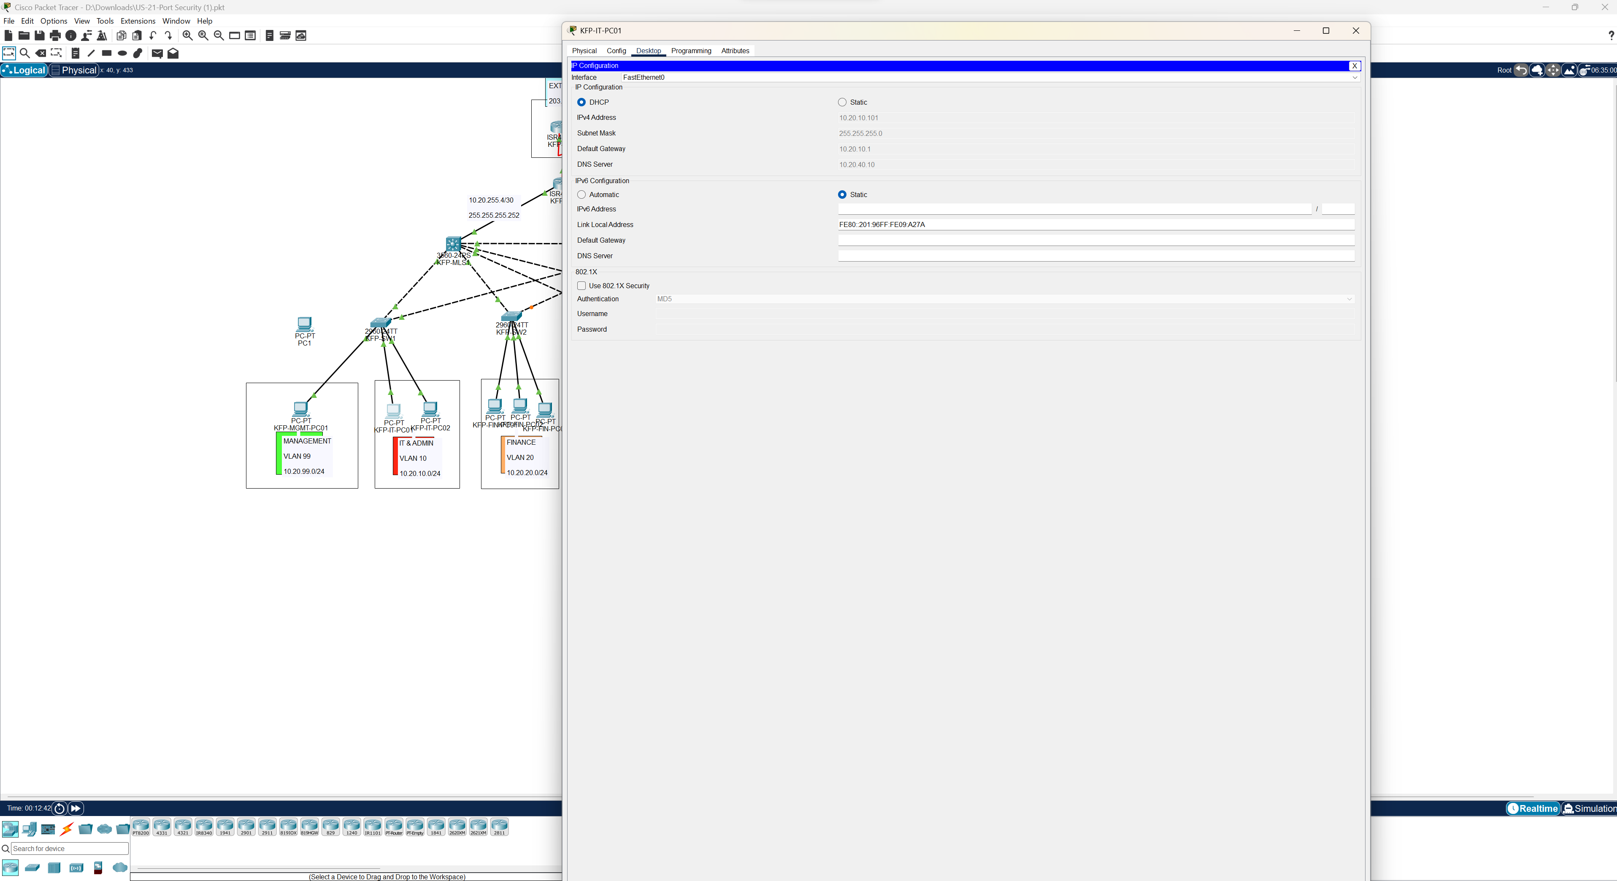

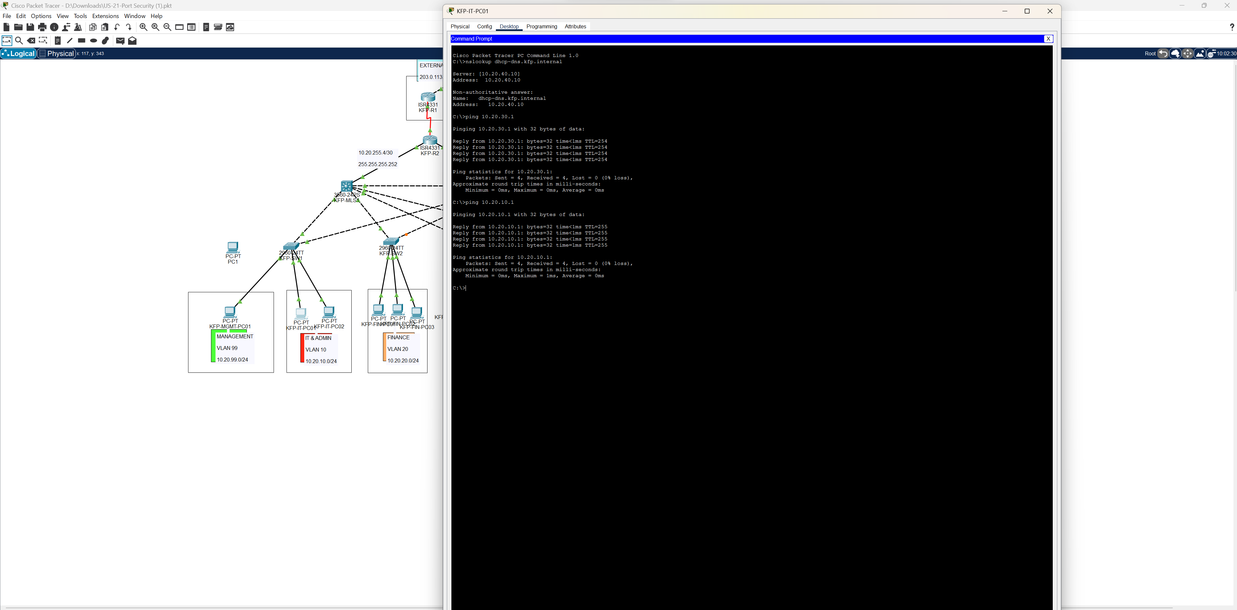

DNS Verification and ping test succeeded as seen in the above screenshot.

Verification of DHCP on VLAN 20:

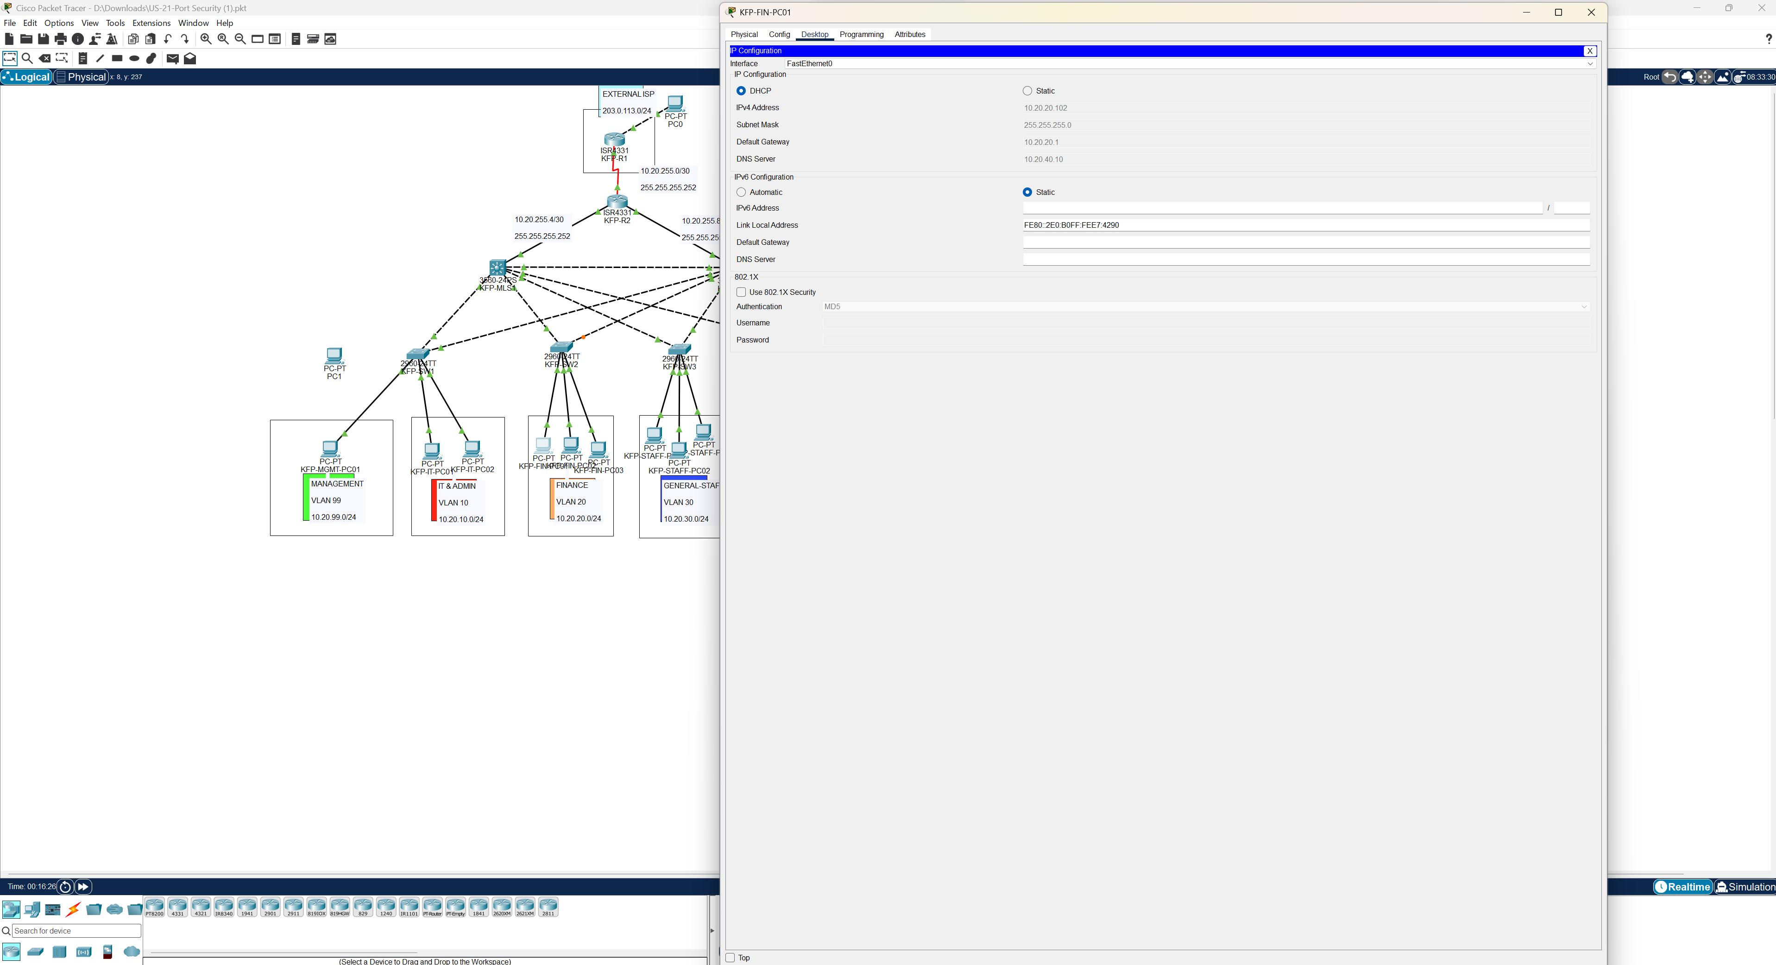

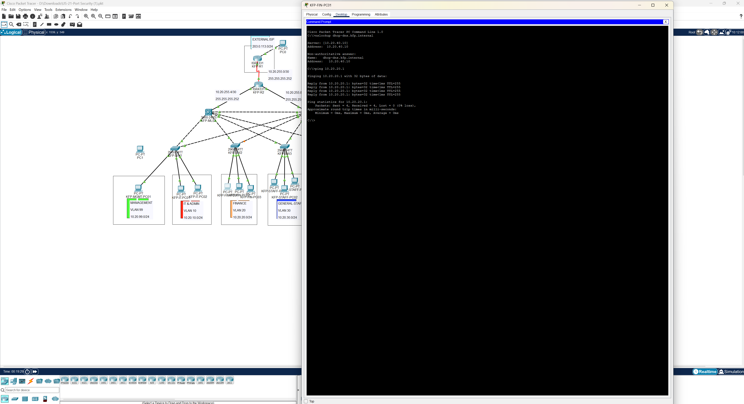
DNS Verification and ping test succeeded as seen in the above screenshot.

Verification of DHCP on VLAN 30:

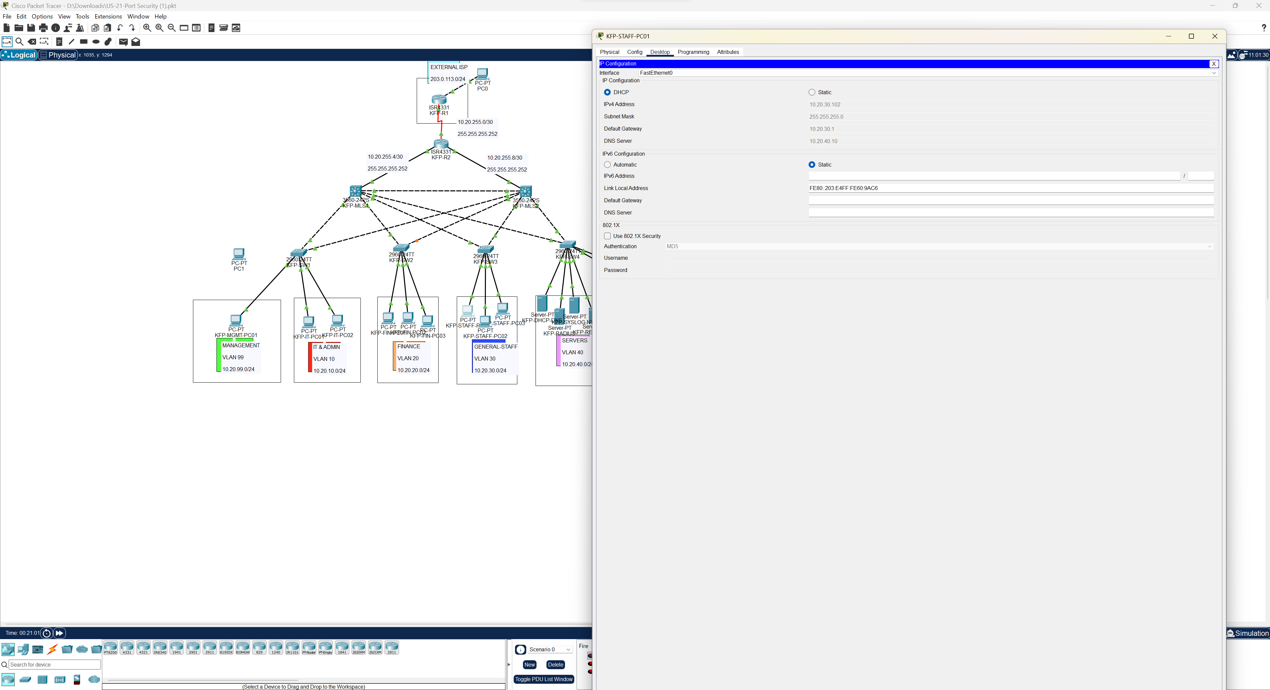

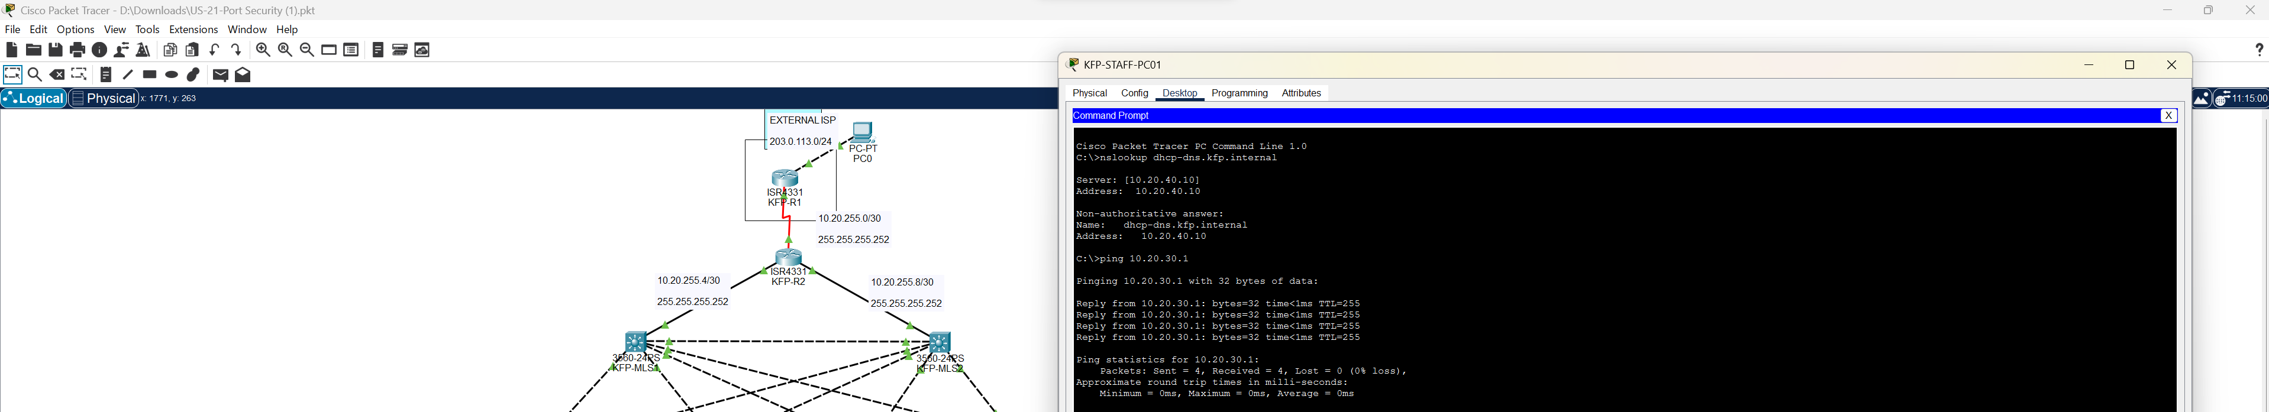

DNS Verification and ping test succeeded as seen in the above screenshot.

Tests were run on all three staff vlans (excluding management). DHCP was tested on a pc in all three, and all three results were as expected. All three PCs returned the expected IP address of the DHCP-DNS server which is 10.20.40.10. Ping tests were also conducted on all three PCs and all of them were successful.

Result: PASS

